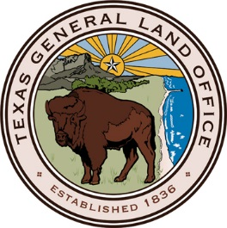

TEXAS GENERAL LAND OFFICE
is
REQUESTING PROPOSALS
for
Community Development Block Grant – Disaster Recovery
Multifamily Rental Housing Program Funding

Release Date: March 15, 2018
Priority Submission Deadline: March 21, 2018 at 2:00 p.m. CDT
Final Submission Deadline: April 15, 2018 at 2:00 p.m. CDT

Solicitation Point of Contact: Debby French, CTPM
Debby.French@GLO.Texas.Gov

Applicants are responsible for checking the Electronic State Business Daily (ESBD) website, http://www.txsmartbuy.com/sp, for the Solicitation and any addenda. The solicitation can be found by searching under Agency Code 305 (General Land Office and Veterans Land Board).

Schedule of Events

EVENT | DATE/TIME
Issue Solicitation | March 15, 2018
Deadline for Submitting Questions | March 19, 2018 at  5:00 p.m. CDT
Priority Deadline for Submission of Solicitation Responses | March 21, 2018 at  5:00 p.m. CDT
Priority Evaluation Period | March 22, 2018 to  April 16, 2018
Final Deadline for Submission of Solicitation Responses | April 16, 2018 at  5:00 p.m. CDT
Final Evaluation Period | April 17, 2018 to  April 30, 2018
Selection and Award Notice | March 22, 2018 to  April 30, 2018
Contract Formation and Negotiation Period | ?
Contract Execution | ?
Deadline for Insurance | ?

Note: These dates represent a tentative schedule of events. The GLO reserves the right to modify these dates at any time prior to the deadline for submission of Solicitation Responses upon notice posted on the Electronic State Business Daily (ESBD) website at: http://www.txsmartbuy.com/sp. Please search under Agency Code 305. Any modification of dates after the deadline for submission of Solicitation Responses will not be posted.

